M/s. Fidelity Insurance & Reinsurance Company SAL – M/s. Extra Four Co. SARL – Wet Damaged Cargo

ULA reference: 250742 – 1v1
Applicant’s Name: M/s Fidelity Insurance & Reinsurance Company SAL
Assured’s Name: M/s. Extra Four Co. SARL
Policy No: MAC-5487814-00-00
12 November 2025


It’s about time you receive the quality of service and expertise your firm deserves.
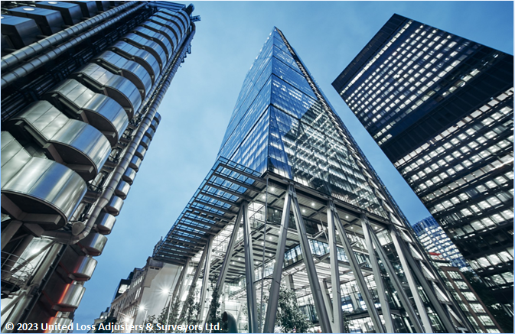

Document Control Page
Attended by: | Written by: | Approved by:
Frank Bruzzese | Hovig Kalandjian | Petro Zaarour
Designation: | Designation: | Designation:
Correspondent Surveyor to ULA | Senior surveyor | UK&I Chartered Engineer, Average & Loss Adjuster
Signature (Approver)

This survey and its issued report were completed without prejudice to all rights of parties concerned.
Date of approval
12 November 2025

Version History | Date of issue | Reason for Revision
1 | 12 November 2025 | Issued – Preliminary report – Pending repair/replacement

The contents of this report are for the confidential information of the client
This survey and its issued report were completed without prejudice to all rights of parties concerned and its concluded adjustment is in accordance with the terms and conditions of the relevant insurance policy.
Contents
ADJUSTER NOTES FOLLOWING ATTENDANCES 5
SILVER NITRATE TEST RESULTS 6
CAUSE OF DAMAGE/LOSS 6
EXTENT OF DAMAGE 6
FINAL CLAIM & ADJUSTMENT 7
CONCLUSION 8
Appendix A – Photograph of container’s hole 10
Appendix B – Photographs of damaged cargo 11

Report & Adjustment Note
At the request of M/s. Fidelity Insurance & Reinsurance Company SAL (the Insurer), the correspondent Surveyor to ULA was requested to attend and investigate a marine cargo claim for M/s. Extra Four Co. SARL (the Assured/Seller/Shipper), quantify the extent of the damage/loss said to have occurred and validate the claim on the subject policy. Table 1 summarizes details pertaining to this claim, and Appendix A includes its representative photographs.
Table 1 - Summary and salient details
Assured’s name | M/s. Extra Four Co. SARL, Beirut, Lebanon
Shipper’s name | M/s. Extra Four Co. SARL, Beirut, Lebanon
Consignee’s name | M/s. Hanna’s Bakery, Ontario, Canada
Insurance Policy | No. MAC-5487814-00-00, Institute Cargo Clause (A) 1.1.2009 CL 382. Warehouse to warehouse.  Replacement clause: In the event of loss or damage to any part of the subject matter insured caused by a peril covered by the policy, the sum recoverable hereunder shall not exceed the cost of replacement or repair of such part (s) plus charges of forwarding and refitting, if incurred but excluding duty unless the full duty is included in the amount insured, in which case loss, if any, sustained by payment of additional duty shall also be recoverable.
Sum insured | Invoiced value including freight = USD 170,500.00
Terms of Sale | CIF as per invoice No. 1210 issued by M/s. Extra Four Co. SARL dated 04 April 2025
Bill of Lading | MEDULB167731 signed on behalf of the Carrier MSC SA, MSC Beirut, dated 14 April 2025.
Cargo Commodities | 2x40’ HC containers STC 396 packages containing bakery equipment with accessories  - 1 x 40’ HC container No. MSDU7488957 STC 89 packages  - 1 x 40’ HC container No. MSNU7491040 STC 307 packages
Damaged container No | 1 x 40’ HC container No. MSNU7491040 STC 307 packages
Routing | Beirut, Lebanon / Montreal, Canada
Mother Vessel | MV “MSC Harmony III” Voyage No. AB517R
Feeder Vessel | MV “MSC RITA V” Voyage No. CD519A
Key dates pertaining to the damage | - Discharge from vessel at final destination: 04 June 2025  - Gated out for delivery: 13 June 2025  - Damage discovery: 13 June 2025  - Notification to ULA from Insurers: 23 July 2025  - First contact with Consignee: 24 July 2025  - Notification to the Carrier: 08 August 2025
Present at the survey | - Mr. Charbel Hanna – Consignee’s Representative  - Mr. Frank Bruzzese – ULA Correspondent Surveyor  The carrier Surveyor abstained from attending

ADJUSTER NOTES FOLLOWING ATTENDANCES
- On 13 June 2025, on the cargo receipt and inspection carried out by the Consignee, it was observed that a large number of bakery accessories were found to be wet, as a result of a hole in container No MSNU7491040's ceiling (Appendix B refers).
- On 21 July 2025, the Consignee notified their insurance broker of the incident, accompanied by a set of photographs and documents.
- On 23 July 2025, the Insurer appointed ULA to conduct an independent inspection of the cargo at the delivery warehouse in Canada.
- An attempt was made to contact the Consignee by telephone on 23 July 2025, but there was no response. The Consignee returned the call on 24 July 2025 and reported that the cargo had arrived with a hole in container No MSNU7491040, resulting in water damage to some of the items.
- The Consignee was asked whether the Carrier, M/s MSC, had been notified at the time of cargo receipt. He confirmed that no such notification was made, stating that this was his first experience with such an incident and he was unsure of the appropriate course of action. ULA also inquired about the delay in reporting the incident to the Insurers, noting that the cargo was received on 13 June 2025, but the notification was only made on 21 July 2025. The Consignee explained that the delay was due to his unfamiliarity with the claims process and uncertainty about how to proceed. This resulted in the recovery rights against the carrier being prejudiced, potentially waiving a valid claim recovery.
- On 28 July 2025, the Consignee submitted a set of photographs clearly showing a hole inside the container, along with images of the wet, damaged items located directly beneath the hole. The Consignee also provided a list of the damaged items that require replacement or repair.
- Based on the photographs received from the Consignee, the following observations were noted:
  - The photographs clearly showed a significant perforation in the container’s ceiling. The hole appeared irregular in shape and size, with a corroded frame, indicating that the damage was not recent.
  - The hole allowed direct exposure to external elements such as moisture and dust.
  - Water was observed on the container’s floor.
  - Several sprockets and shafts in the chain drive system showed visible signs of rust and corrosion, particularly around the shaft ends and teeth.
- On 08 August 2025, the correspondent Surveyor to ULA served the attached letter of reserve to M/s. MSC as the Carrier holding them liable for the loss and invited them to a joint survey on the same day at the Consignee warehouse.
- On 11 August 2025, the Carrier informed that after review of the case, MSC will not be joining the joint survey. And that the container was delivered to the Consignee on 13 June 2025, and as such, MSC would like to bring attention to clause 10 of MSC’s Terms and Conditions.
Quote:
10.1 Notice - of loss or damage to Goods shall be given in writing to the Carrier or its agent at the Port of Discharge before or at the time of delivery. If the loss or damage is not apparent before or at the time of delivery, notice must be given within three (3) days of delivery to the Merchant or its agent. Claims shall be submitted in writing addressed by the Merchant to the Carrier’s agent at the Port of Discharge.
Unquote
While MSC’s arguments were noted, it is important to note that the loss and damage to the cargo could not be discovered on immediate delivery and were formed over time naturally as a result of wetting damage.
- A survey was conducted at the Consignee’s warehouse in the presence of the Consignee’s representative, Mr. Charbel Hanna. The observations made during the survey are as follows:
  - Extensive rust formation: Metal components of the machines exhibited significant rusting, particularly along the exposed sections of all shafts. The corrosion was unevenly distributed, indicating prolonged and uncontrolled exposure to moisture.
  - Accelerated corrosion due to environmental exposure: Continuous exposure to high humidity and water has accelerated corrosion across various metal parts, leading to notable degradation in both structural integrity and mechanical functionality.
  - Mechanical failures from moisture ingress: Moisture and contaminants have adversely impacted critical components such as bearings, motors, and belts. This has resulted in reduced performance, frequent malfunctions, and potential system breakdowns.
  - Damage to electrical accessories: Accessories, including electrical cables, connectors, and sensors, have been compromised due to moisture penetration. Several are now non-functional and present safety risks due to potential short circuits or insulation failure.

SILVER NITRATE TEST RESULTS
An in-house silver nitrate test was conducted on the affected samples to determine the nature of the water contamination. The test results confirmed the presence of chloride ions in the collected moisture from the damaged accessories.
This finding strongly indicates that the source of water exposure is of seawater origin. The presence of chloride ions, commonly associated with saline environments, supports the conclusion that the observed corrosion and deterioration of the equipment and accessories are consistent with damage caused by seawater contamination.
Based on this analysis, it is evident that the water-related damage sustained by the cargo resulted from exposure to seawater rather than freshwater or other sources.

CAUSE OF DAMAGE
It is in the opinion of the undersigned that the proximate cause of the damage to cargo in container No MSNU7491040, weighing around 1,700 kg (10% of the cargo weight), is attributed to direct exposure to seawater, which infiltrated through the container’s punctured roof ceiling, visible in its structure, resulting in widespread corrosion contamination and damage to the cargo.
As a result, critical mechanical and electrical parts, such as shafts, bearings, motors, belts, sensors, and cables, have suffered significant corrosion and water contamination damage, compromising their integrity, functionality, and safety, noting that these are produced to food-grade standards.
The extent and pattern of deterioration are consistent with prolonged or repeated exposure to seawater, directly resulting from the container’s structural failure and the consequent ingress of marine water.

EXTENT OF DAMAGE
Inspection of the bakery machine’s chain drive system revealed both visible and non-visible damage resulting from moisture exposure and corrosion. Several sprockets and shafts exhibit clear signs of rust and surface corrosion, particularly concentrated around shaft ends and the sprocket teeth. This corrosion not only affects the appearance but also compromises the mechanical integrity of these components.
Internally, moisture ingress has impacted critical elements such as bearings, bushings, and motors. Although not immediately visible, this internal damage has led to premature mechanical failures and a marked decline in operational efficiency. Affected bearings and bushings are likely to experience increased friction and wear, which contributes to overall system degradation and reduced reliability.
The rusted sprockets pose a significant operational concern, as the corroded surfaces can cause abrasive wear on the chain. This would result in elevated friction, potential misalignment, and even jamming during machine operation, each of which can interrupt production and increase maintenance costs.
Importantly, because the damaged machinery and accessories are part of a food-processing system, the presence of rust or contamination on any mechanical component introduces serious hygiene risks. Food-grade equipment is required to be free from corrosion and designed for easy cleaning and sanitization. The current condition of the chain drive system renders the equipment non-compliant with hygiene standards, raising potential food safety concerns and making it unsuitable for continued use in a food production environment without thorough remediation or replacement.

REPLACEMENT VS LOCAL REPAIR OPTION
The policy incorporates a replacement clause, on the basis of which the Assured obtained a quote for replacing affected parts from the supplier in Lebanon, which amounted to USD 39,435.45.
ULA further examined the option to repair the machine locally. The latter option proved to be uneconomic as it resulted in a higher cost, USD 63,280.00. As such, the first option to replace affected components was selected accordingly. Supporting documents for both options are enclosed in support of the claim.

FINAL CLAIM & ADJUSTMENT
On receipt of the official invoice No. 1210, issued by M/s. Extra four Co. SARL dated 04 April 2025, Table 2 below outlines the claimed and proposed adjusted policy indemnity.
In the absence of a completed salvage sale, the proceeds were estimated based on the local representative market rate for scrap. Additionally, a theoretically realized recovery, reflecting the prejudice to Insurers’ rights, was accounted for. The final proposed policy settlement is outlined below.
Table 2 - Claim & Adjustment on the policy
Qty | Description | Unit cost in USD | Damaged cost in USD | Adjusted Amount in USD
2 | Sheeter drum with felt W950 complete | 650.00 | 650.00 | 1,300.00
2 | Felt belt 1550x950 Ammeraal | 125.00 | 125.00 | 250.00
2 | Felt belt 2350x950 Ammeraal | 186.00 | 186.00 | 372.00
2 | Belt 900x1050 with CG CHIORINO | 105.00 | 105.00 | 210.00
2 | Belt 3050x1050 with CG CHIORINO | 330.00 | 330.00 | 660.00
2 | Belt 4050x1050 CG Ammeraal | 348.00 | 348.00 | 696.00
8 | Belt 3100x150 CHIORINO | 48.00 | 48.00 | 387.00
2 | Belt 2000x1100 HEAT RESISTANT OV | 58.00 | 58.00 | 116.00
1 | Felt thick 1650x600 Ammeraal | 116.00 | 116.00 | 116.00
13 | Belt 14000x1100 Ammeraal | 698.00 | 698.00 | 9,074.00
1 | Belt 14400x1100 Ammeraal | 718.00 | 718.00 | 718.00
1 | Belt 17000x1100 Ammeraal | 746.45 | 746.45 | 746.45
5 | Felt belt 10700x600 CG Ammeraal | 518.00 | 518.00 | 2,590.00
1 | Felt belt 11500x600 CG Ammeraal | 557.00 | 557.00 | 557.00
1 | Felt belt 12000x600 CG Ammeraal | 581.00 | 581.00 | 581.00
1 | Felt thick 900x130 Ammeraal | 25.00 | 25.00 | 25.00
1 | Felt thick 1370x130 Ammeraal | 30.00 | 30.00 | 30.00
1 | Felt thick 1840x130 Ammeraal | 35.00 | 35.00 | 35.00
1 | Felt thick 2310x130 Ammeraal | 40.00 | 40.00 | 40.00
35 | Block bearing UCFL 206 NBR | 12.00 | 12.00 | 12.00
1 | Motor 2.2kw 60rpm F.P. Germany UL | 980.00 | 980.00 | 980.00
1 | Motor 1.5kw 60rpm F.P. Germany UL | 831.00 | 831.00 | 831.00
4 | Sensor CM30 SICK | 95.00 | 95.00 | 95.00
6 | Shaft for cooling conveyor W1100 | 80.00 | 80.00 | 25.00
16 | Steel shaft for Final Proofer 60mm L1100 Fixed | 180.00 | 180.00 | 110.00
16 | Steel shaft for Final Proofer 60mm L1100 Rotating | 230.00 | 230.00 | 130.00
20 | Chain 12B BEA | 18.50 | 18.50 | 18.50
16 | Sprocket 12B N15 Keyway & Threaded | 35.00 | 35.00 | 15.00
4 | Piston 25/100 | 95.00 | 95.00 | 95.00
6 | Block bearing UCFL 205 NBR | 10.00 | 10.00 | 10.00
6 | Steel shaft for Sheeter 60mm L1050 Fixed | 175.00 | 175.00 | 175.00
9 | Block bearing UCHA 205 NBR | 16.00 | 16.00 | 16.00
6 | Scrapper Blade 35mm L1050 | 25.00 | 25.00 | 25.00
2 | VFD 2.2 kw programmed | 650.00 | 650.00 | 650.00
1 | VFD 1.5 kw programmed | 560.00 | 560.00 | 560.00
1 | HMI screen 4.5" | 480.00 | 480.00 | 480.00
Claimed Amount ------------------------------------------------------------------------------------- USD 29,935.45
Add labour cost --------------------------------------------------------------------------------------- USD 6,000.00
Add freight charges ---------------------------------------------------------------------------------- USD 3,500.00
Less salvage sale (1,700 kg x USD 1,000/ton) -------------------------------------------------- USD 1,700.00
Less recovery (40%) -------------------------------------------------------------------------------- USD 15,094.18
Total amount of loss ------------------------------------------------------------------------------- USD 22,641.27

CONCLUSION
In our opinion,
- The claim presented by the Assured amounting USD 22,641.27 is fair and reasonable.
- The subject cargo was adequately insured at the time of the loss; the Assured had insurable interest, and Insurers were on risk.
- This claim should be recoverable under the policy pursuant to Clause 1 of the Institute Cargo Clauses (A) CL 382, as it constitutes a fortuitous loss to the subject-matter insured caused by seawater ingress into the container while in the custody of the carrier.
- The carrier M/s. MSC should be held liable for the loss of the subject cargo for failing to care for the subject cargo whilst in their custody, having provided an uncargoworthy container.
We confirm that we have sighted the originals of all documents made available and customarily submitted, in support of a claim of this nature.
End of adjustment note.
Enclosed Documents:

- Certificate of insurance No MAC-5487814-00-00
- Bill of Lading No MEDULB167731
- Invoice No 1210
- Packing list
- Container tracking
- Certificate of origin
- Letter of reserve to MSC
- Extent of loss – Replacement invoice issued by the Assured/Supplier/Buyer
- Local repair invoice amounting to USD 63,280.00

Appendix A – Photograph of container’s hole
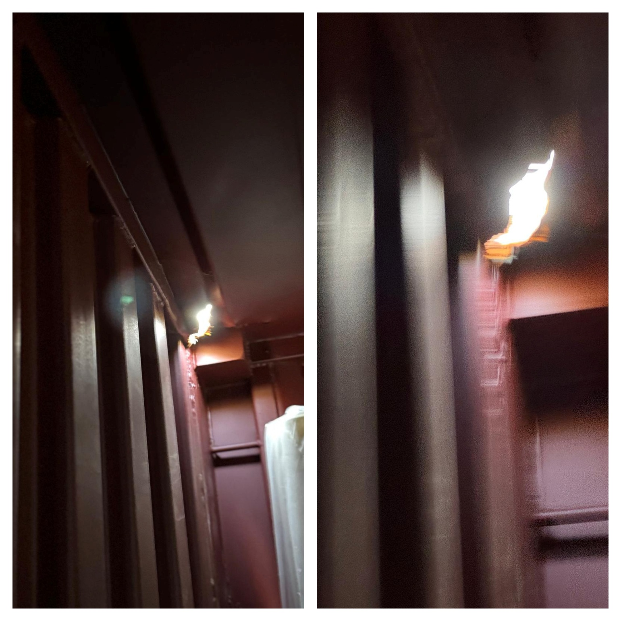

Appendix B – Photographs of damaged cargo
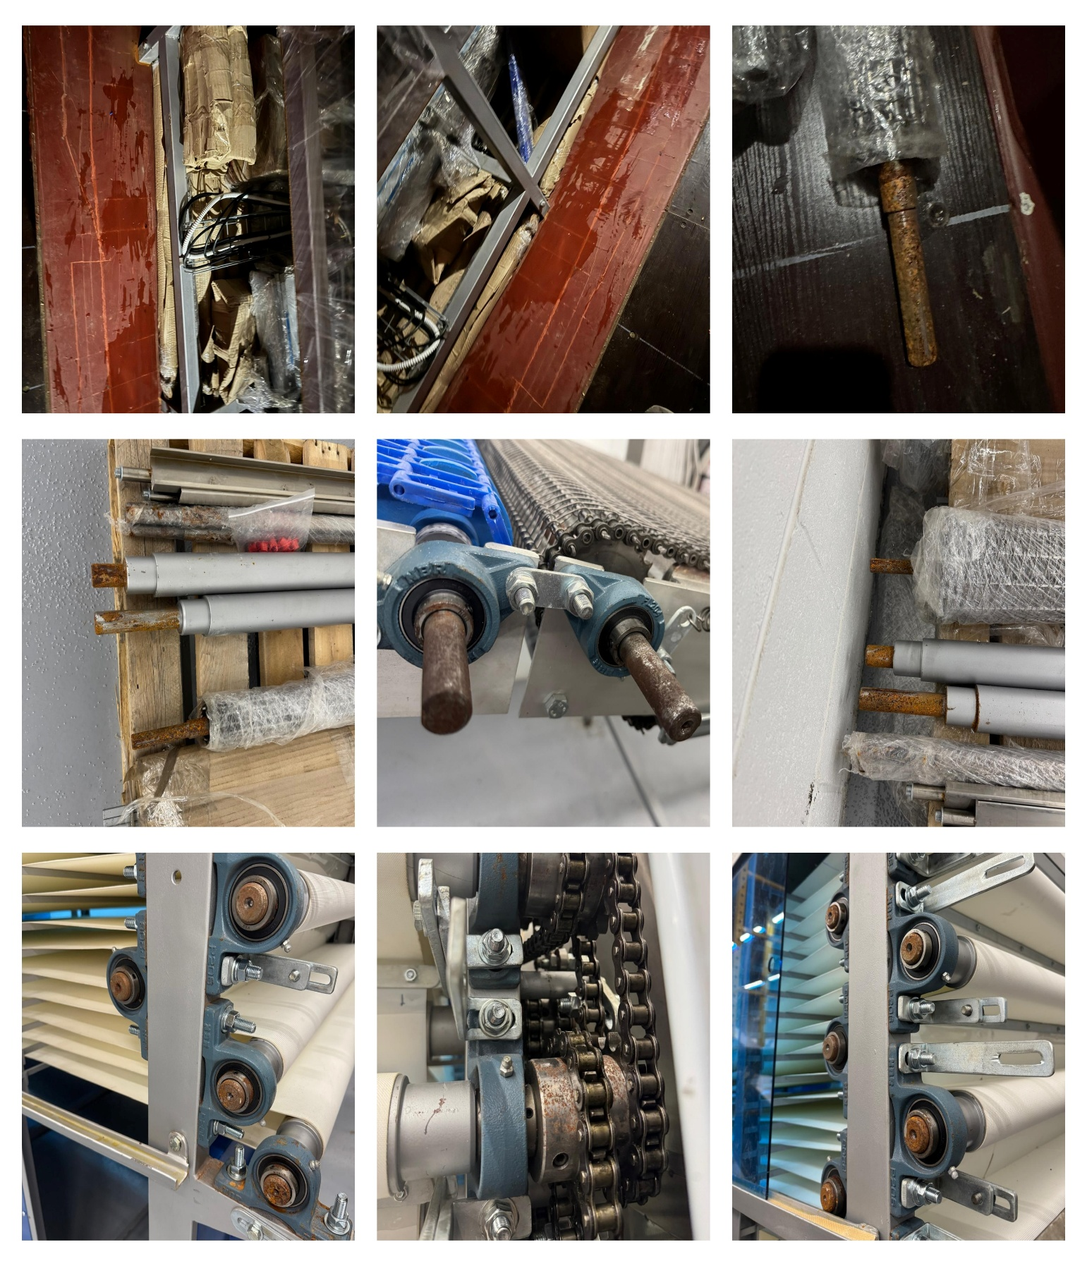

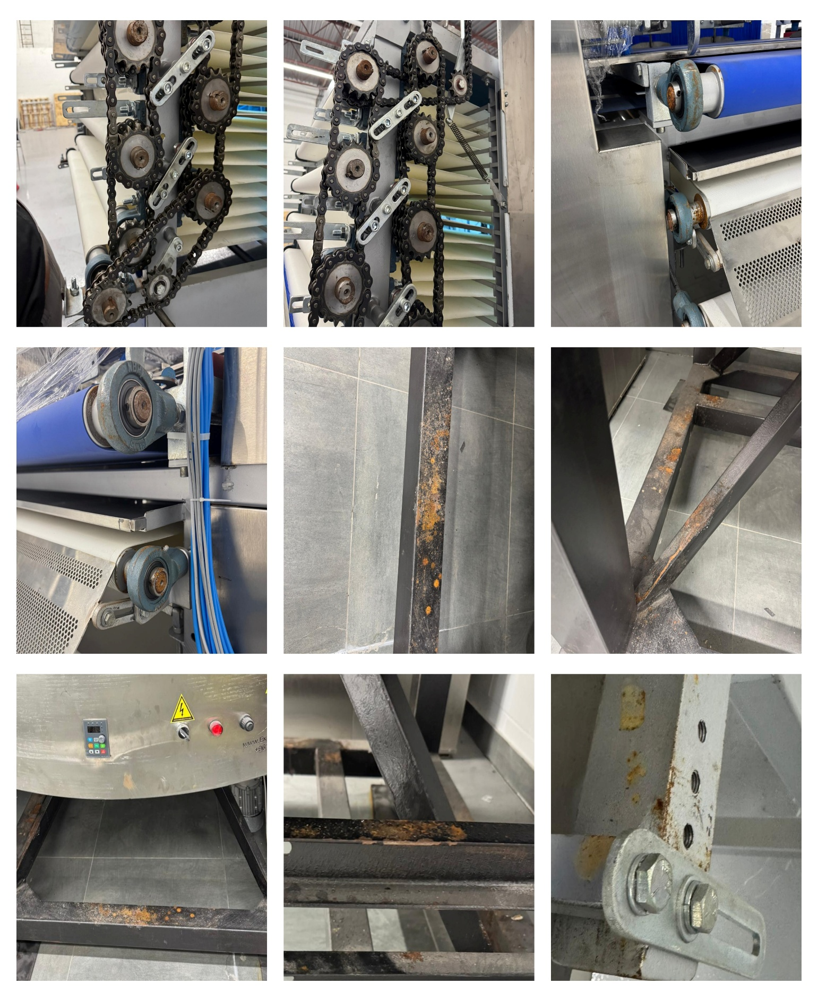
About ULA
United Loss Adjusters and Surveyors (ULA) is a leading international provider of Adjusters, Surveyors, Solicitors and Consultants, offering unrivalled technical and legal solutions with exclusive access to the London Market's leading specialists.
Founded in 2002, with strategic head offices in the Middle East and the United Kingdom, today ULA is the strategic ally of a world-leading legal firm Clyde & Co. (with offices in over 60 major countries) and the correspondent for a number of global technical service providers such as Charles Taylor Adjusting (with offices in 140+ countries), with principals including but not limited to Insurers, Reinsurers, Brokers, P&I clubs, Ship Owners, Shipyards and Agencies.
Lines of business:
- Insurance & Re-insurance
- Claims solutions and loss adjusting across all major lines: aviation, cargo, marine, property, fine arts and special risks claims
- Cargo & Containers
- Marine & Offshore
- Global Claim Recoveries & Legal Support
Our team:
Our team of qualified professionals experienced in the fields of Marine, Insurance, Finance, Engineering and Law known and respected for their integrity and credibility. Supported by a highly mobile team strategically positioned where our services are needed, we are always available on short notice to deal promptly with your queries. ULA is independent to the core and can be trusted to express unbiased views, and is not influenced by stakeholders.
ULA’s team members are recognised:
- Chartered Engineers
- Consultants
- Inspectors & Auditors
- Insurance & Re-Insurance Underwriters
- Loss & Average Adjusters
- Master Mariners & Chief Engineers
- Naval Architects, Marine & Offshore Engineers
- Solicitors
- Sworn Surveyors
ULA’s team members are also recognised members of the following international institutions:
- The Association of Average Adjusters (AAA)
- The Bar Council of England and Wales
- The Chartered Insurance Institute (CII)
- The Chartered Institute of Loss Adjusters (CILA)
- The European Federation of Loss Adjusting Experts (FUEDI)
- The Institute of Fire Engineers (IFE)
- The Institute of Marine Engineering, Science and Technology (IMarEST)
- The UK Engineering Council
- The Royal Institute of Naval Architects (RINA)
- The International Institute of Marine Surveying (IIMS)
- The Royal Institute of Chartered Surveyors (RICS)

Contact person
Hovig Kalandjian
Senior Surveyor
United Kingdom: 71-75 Shelton Street, Covent Garden | London, England - WC2H 9JQ
Middle East: Mina Tower, Ain Waraka Street | Beirut, Lebanon - WG2G+5CX

Registered name United Loss Adjusters and Surveyors Ltd.

24/7 Contacts & Claim Support – T: +44 (0) 20 3287 3326 | M/WhatsApp: +44 (0) 7 375 110 573
Office E: claims@unitedlossadjusters.com
W: https://www.unitedlossadjusters.com/



